UNIVERSITY OF SCIENCE - VNUHCM
FACULTY OF INFORMATION TECHNOLOGY

OBJECT-ORIENTED PROGRAMMING REPORT
SUBJECT: MANAGEMENT SYSTEM APPLICATION

Instructor:
Võ Nhật Tân
Trương Tấn Khoa
Students:
Huỳnh Phúc Nguyên
Đỗ Minh Khang
Nguyễn Viết Bách
Lâm Hồng Hải Hoàng Lê
Dương Anh Hào

ACKNOWLEDGEMENTS

GROUP INTRODUCTION

General information

Group ID: 01
Student ID | Full Name | Email
25127106 | Huỳnh Phúc Nguyên | hpnguyen2527@clc.fitus.edu.vn
25127045 | Dương Anh Hào | dahao2532@clc.fitus.edu.vn
25127207 | Lâm Hồng Hải Hoàng Lê | lhhhle2508@clc.fitus.edu.vn
25127275 | Nguyễn Viết Bách | nvbach2517@clc.fitus.edu.vn
25127363 | Đỗ Minh Khang | dmkhang2525@clc.fitus.edu.vn

Member roles and task assignments

Full Name | Assigned Tasks | Contribution (%)
Huỳnh Phúc Nguyên
Dương Anh Hào
Lâm Hồng Hải Hoàng Lê
Nguyễn Viết Bách
Đỗ Minh Khang

PROBLEM STATEMENT

Selected management topic
A Warehouse Management System (WMS) has been selected as the core topic for this project to simulate and solve common inventory tracking challenges through an object-oriented approach. In traditional manual systems, reliance on paper records or simple spreadsheets often leads to frequent data discrepancies, delayed updates during stock intake, and general inefficiencies. For an academic programming project, this domain provides a highly practical environment to demonstrate four Object-Oriented Programming (OOP) concepts: Encapsulation, Inheritance, Polymorphism, and Abstraction. Furthermore, to ensure the software architecture is scalable and follows clean coding standards, the system will integrate at least two design patterns, specifically the ... Pattern and the ... Pattern, which will decouple object creation and behavioral interactions within the system.

Target Users
The system categorizes target users into three main operational roles to establish basic access control and reflect a standard warehouse environment.
- Inventory Managers oversee the general state of the warehouse by monitoring stock levels, approving inbound or outbound requests, defining safety thresholds for reordering, and viewing system reports.
- Warehouse Staff handle day-to-day operations on the floor, interacting directly with the program to perform physical stocktakes, update item storage locations, and log new stock movements.

Main features
The main features of the application are divided into core functional modules that cover the fundamental workflows of warehouse management.
- Product and Inventory Management handles essential CRUD (Create, Read, Update, Delete) operations, allowing users to maintain accurate digital profiles of items, track quantities, and record storage locations.
- Inbound Management simplifies the receiving process by logging incoming items from suppliers, verifying quantities against purchase records, and generating receipt notes to update the system's inventory.
- Outbound Management manages the shipping process by processing order requests, creating picking lists for staff, reducing the available stock counts, and issuing outbound delivery notes.

Input and output data

SYSTEM DESIGN
  - UML Class Diagram
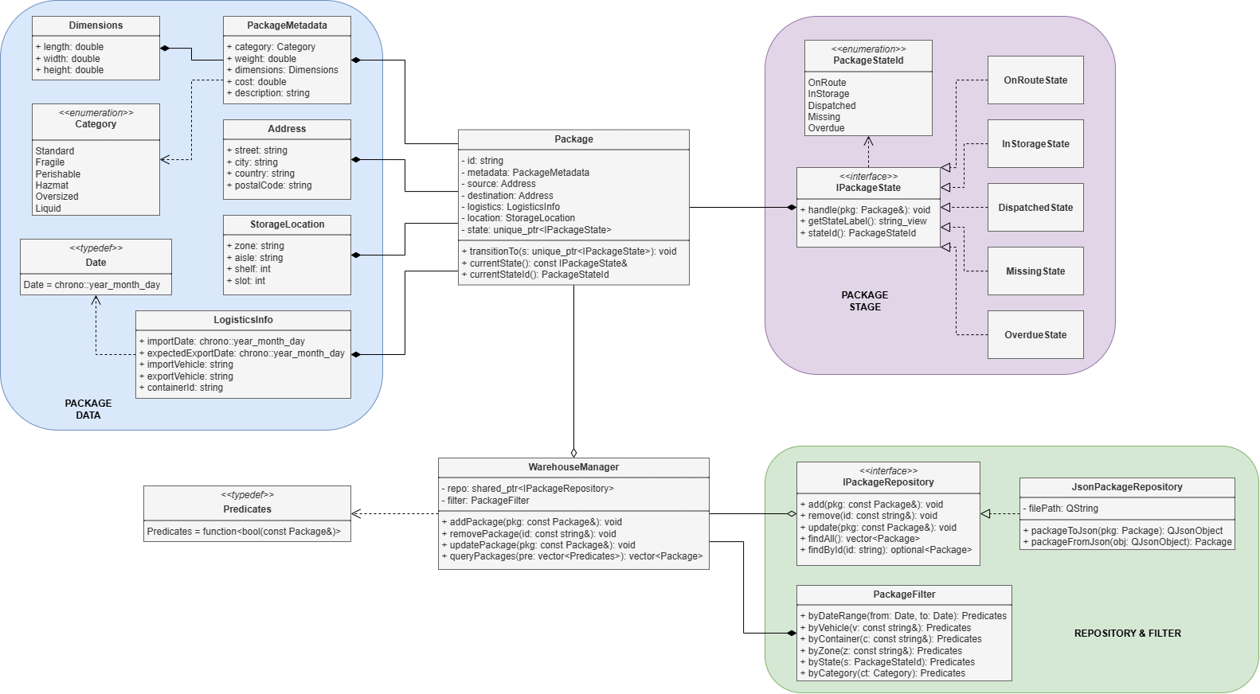
Image 3.1.1. UML Warehouse management system

  - Main classes and relationships

  - Application flow or main use-case flow.
  - Project structure.

PROJECT ARCHITECTURE

IMPLEMENTATION AND TESTING

AI USAGE AND INDIVIDUAL ACCOUNTABILITY

CHALLENGES AND FUTURE ENHANCEMENTS

REFERENCES

APPENDICES

